Inside Yahoo! Generator
Thai Tran
CS224N Final Project
June 6, 2002

Introduction
When a user performs a search on Yahoo, the first section of results that is returned is called the “Inside Yahoo! Matches.” This section is designed to highlight the content inside the Yahoo network that is most relevant to the user’s search. For example, a search for “blue book” will return a link to the Kelley Blue Book used car pricing guide in Yahoo! Autos. Currently, there is an editorial team who manually determines which Yahoo property (Autos, Careers, Travel, etc.) should be featured in the Inside Yahoo match and what page on that property the link should go to. The goal of this project is to employ a machine-learning algorithm to automatically determine the contents of the Inside Yahoo match based on previous choices that the editorial team has made. More generally, the system will determine what other search terms are most similar to the one being examined. For example, if the system learns that “kelley auto guide” is similar to “blue book,” then it is likely that the Inside Yahoo matches for the two search terms are also similar.

Corpus
I selected 50 existing Inside Yahoo search terms from each of the following six categories: Autos, Careers, Maps, Personals, Sports, and Travel. To remove any possible bias, I had an automated process select the terms that were most frequently searched for on Yahoo and had high click-though rates. Unfortunately, this meant that the autos data set was extremely skewed towards search terms that related to the Kelley and Edmunds auto guides, which are very popular among users.

Representation of Search Terms
For each search term, I needed a set of attributes to describe it. I considered using either the contents or the editorial descriptions of the first twenty web site hits in the Yahoo Directory as the representation of the search term. However, there were two problems with this approach: First, the number of web sites in the Yahoo Directory numbers in the millions whereas the number of documents on the web is believed to be in the billions. Second, the descriptions of the web sites in the Yahoo Directory have been edited to be consistent and free from spelling and grammatical errors, which prevented me from obtaining a representation for misspelled search terms and terms that are expressed differently from what the Yahoo editors had chosen. For example, a search for “jamica” (misspelling of “jamaica”) returns 0 web site results from the Yahoo Directory. Instead, I chose to use the contents of the first twenty web page matches from Google (which claims to index over 2 billion documents) as the representation for each search term.

Parsing Web Pages
I took the following approach to extracting the words from a web page:
- Delete all <script>…</script> and <style>…</style> blocks
- Strip all HTML escape sequences
- Strip all HTML tags
- Strip all non-alphanumeric characters
- Lowercase all characters
- The remaining sequence of word tokens is the representation for the web page

Additionally, the word tokens were stemmed using Porter’s Stemming Algorithm [4]. Haveliwala, et al have shown that stemming using this algorithm improves the performance of the similarity metric that we will be using in this project [2].

There are several major challenges to determining the contents of web pages:
- Non-understanding of HTML tags: Since I had stripped away all tags from the document, I did not know whether two words that were collated in the resulting sequence would actually be collocated when the original document was rendered in a browser.
- Page Not Found / This Document Has Moved: When page is no longer available, the web server is supposed to return a 404 response via the HTTP protocol, and when a page has moved, the server is supposed to return a 302 response. Our routine to fetch web pages knows how to correctly deal with these situations. However, many web sites will either redirect your request to their home page or will display an error message but will still return a 200 (OK) response. This causes the contents of unintended pages to be used in our similarity metric.
- Splash Pages: Some web sites have a splash page that contains no content, and refreshes after some delay to send you to the real content. To solve this problem, we would need to detect the <meta> refresh tag and fetch the contents of the next page.
- Frames: Pages that contain frames themselves contain no content. A solution to this problem could be to fetch all the sub-frames and combine them to form the document that we save.
- All Graphics/Flash: Some web pages contain nothing but graphics or Macromedia Flash objects, so there is no text to extract from them.
- JavaScript/DHTML: Some web pages are dynamically generated from JavaScript code. Without being able to parse and execute JavaScript, we are unable to deduce the contents of the page.

Despite these challenges, I have found that these aberrations are a minority in the data set.

Similarity Metric
I used the metric introduced by Broder, et. al. [1] to determine the similarity of two documents. Each document is represented as a sequence of word tokens. A contiguous subsequence of tokens in the document is called a shingle. We define the n-shingling S(D, n) as the set of all shingles of length n in document D.

For example, if a document D is the following sequence:

D = (a, rose, is, a, rose, is, a, rose)

Then the 4-shingling of D is the following set:

S(D,4) = { (a, rose, is, a), (rose, is, a, rose), (is, a, rose, is) }

For a given shingle size, the resemblance r of two documents A and B is defined as:
r(A,B) =
|S(A) ∩ S(B)|

|S(A) ∪ S(B)|

Hence, the resemblance scales from 0 to 1, with 0 being no resemblance and 1 being perfect resemblance. Note that a document A always resembles itself 100%: r(A,A) = 1. However, resemblance is not transitive. It is possible for r(A,B) = 50% and r(B,C) = 50% and r(A,C) = 0%.

Note: This entire explanation was shamelessly stolen from [1].

Stop Words and Stop Shingles
To decrease the memory requirement and to remove noise from the data set, the most commonly occurring words (the stop words) were removed the web pages prior to shingling them. Post shingling, I found that there were certain phrases that occurred very frequently in the data set but did not aid in the classification of search terms. Examples were ‘click,here’, ‘privacy,policy’, ‘site,map’ and ‘ar,regist,trademark’. All commonly occurring shingles (the stop shingles) were also removed from the data set.

Validating the Similarity Measure
To validate that this approach was a good measure for web page similarity, I calculated the resemblance of each search term in the corpus against every other search term in the corpus. I then averaged the resemblance of the search terms in each category-to-category pair. For example, the resemblance of “find date” and “find job” was averaged into the personals-careers pair. Note that the value of personals-careers is the same as the value of careers-personals. I performed this for shingle sizes of 1 through 4.

In all cases, the resemblance of a category to itself was higher than its resemblance to any other category. As the shingle size increased, the absolute values of the resemblances decreased, but there was increasing differences between the self-resemblances and the non-self resemblances. For shingle sizes of 2 and greater, the differences were dramatic.

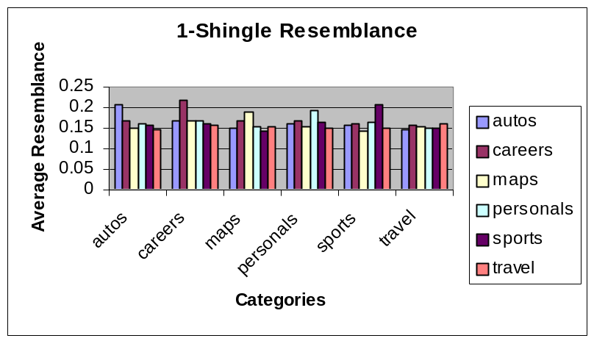

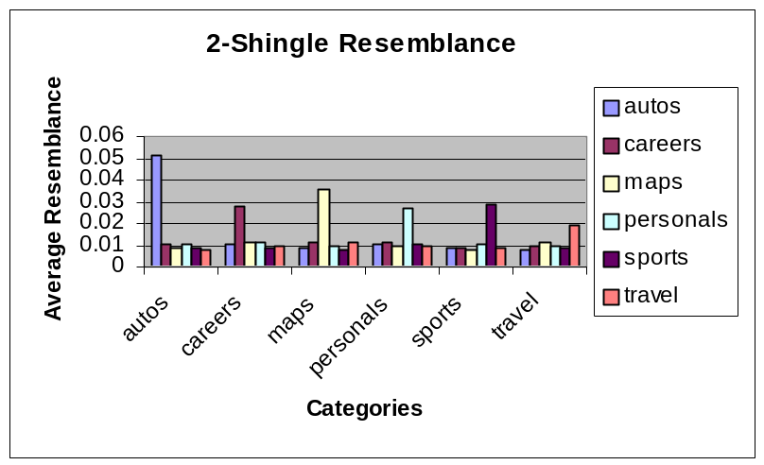
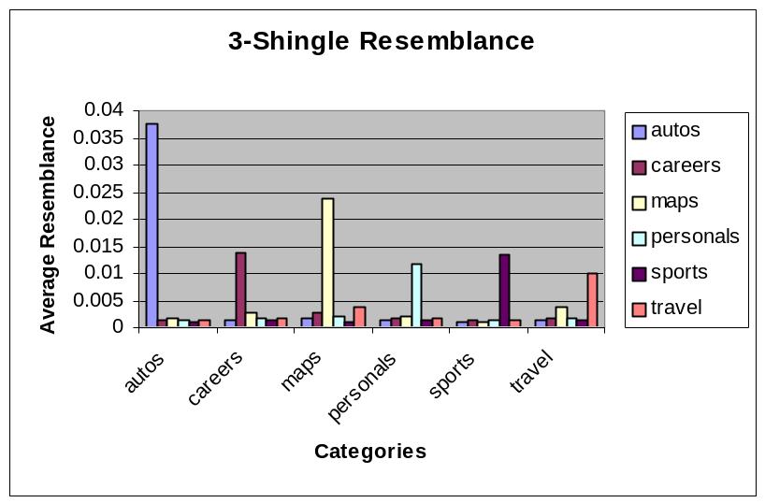

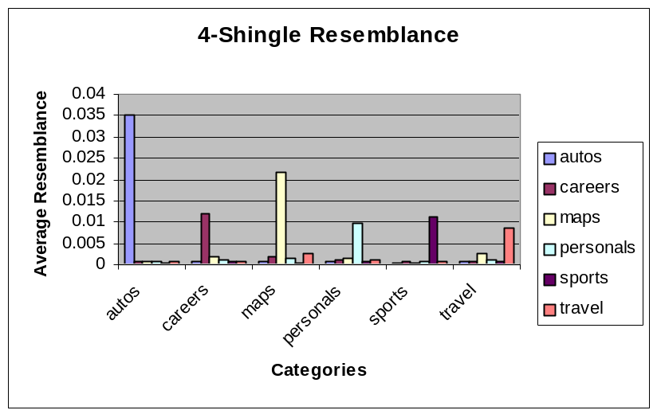

As the shingle sizes increase, the number of distinct shingles that represent each document also increases. In practice, I found that the total number of shingles in the dataset (and hence the amount of memory and computation required to calculate resemblance) would approach a limit after a shingle size of 5.

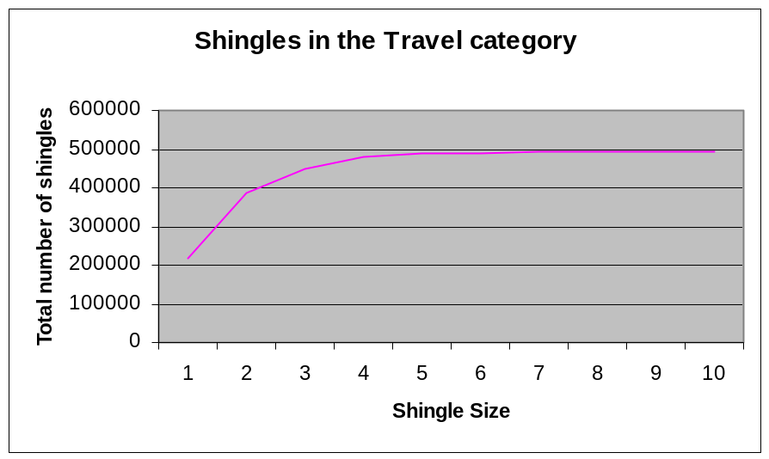

However, the downside of large shingle sizes is that the data also becomes sparser. In the same category pairs (e.g. autos-autos), I counted the number of search term pairs that were orthogonal – that had no shingles in common. In the corpus, I found that there were no orthogonal search term pairs when using shingle sizes of 1 and 2, 0.2% of the pairs were orthogonal when using a shingle size of 3, and 6.6% of the pairs were orthogonal when using a shingle size of 4.

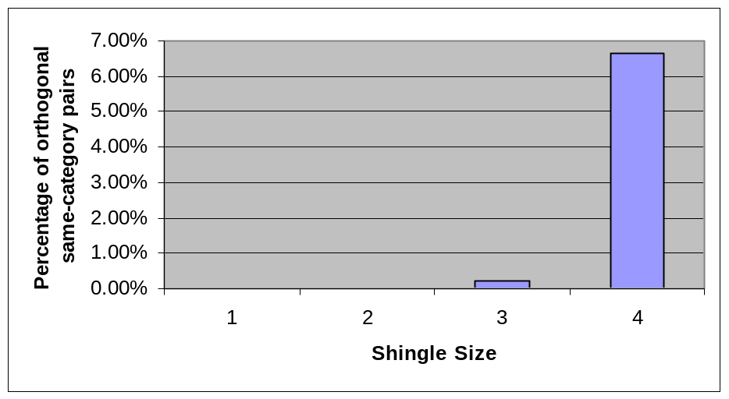

Naïve Algorithm
The goals of the algorithm is given a previously unseen search term s:
- Determine the category that s should belong to
- Determine what other search terms are most similar to s.

This is the first version of the algorithm that I tried that achieved these goals:

Setup phase:
For each search term t in the corpus (tagged with a category c):
Get the top twenty web page matches from Google for the search term
Download and shingle each of the web pages
Combine the shingles (removing duplicates) and save them in the database
as the representation for t

Classification phase:
For each previously unseen search term s:
Get the top twenty web page matches from Google for the search term
Download and shingle each of the web pages
Combine the shingles (removing duplicates)
For each search term t in the database:
Calculate the resemblance between s and t
Remember the t that had the highest resemblance

We then assign s to the same category as the search term that had the highest resemblance to it.

To evaluate this algorithm, I removed one search term from the corpus and attempted to classify it using the remaining search terms I the corpus. I repeated this for every single search term in the corpus using shingle sizes from 1 to 4. I then measured the number of search terms that were assigned to the correct category. For this data set, the shingle size of 2 provided the most accurate categorization.

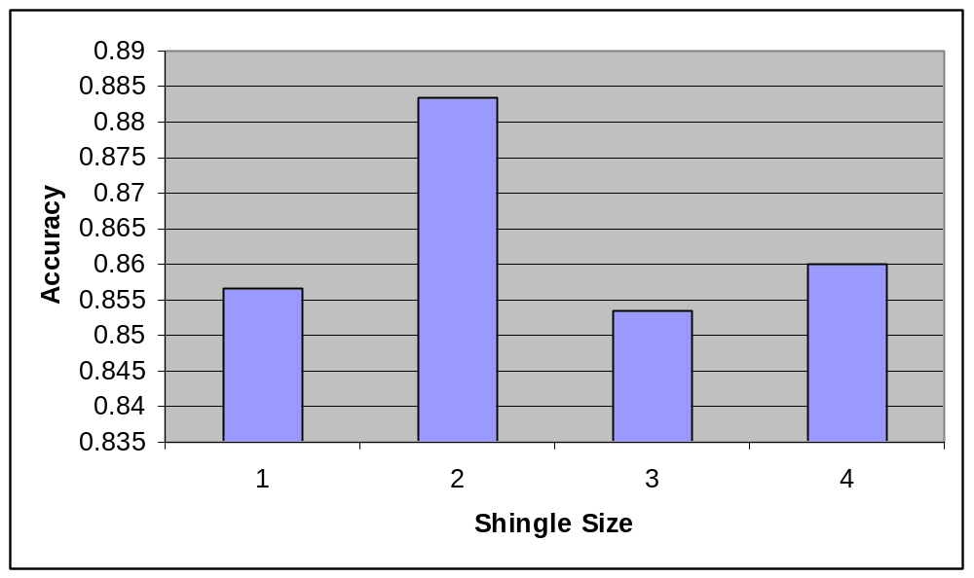

Improving Performance
To reduce the amount of computation required by the classifier, I separated the categorization and search term selection steps. First, I combined all the shingles from the search terms in a particular category and discarded all uncommon shingles (that occurred 3 times or less). This greatly reduced the number of shingles needed to represent the category. I them found the category that had the highest resemblance to the new search term. From here, I only examined the search terms in the matching category for resemblance.

The algorithm was changed as follows:

Setup phase:
For each search term t in the corpus (tagged with a category c):
Get the top twenty web page matches from Google for the search term
Download and shingle each of the web pages
Combine the shingles and save as them in the database as
a representation for t (removing duplicates)
Also append the shingles (not removing duplicates) in the database into the
representation for c

For each category c:
Retrieve all the shingles for c from the database
Delete all shingles that occurred 3 or less times
Save the shingles to the database (removing duplicates) as a representation for c

Classification phase:
For each previously unseen search term s:
Get the top twenty web page matches from Google for the search term
Download and shingle each of the web pages
Combine the shingles (removing duplicates)
For each category c in the database:
Calculate the resemblance between s and c
Remember the c that had the highest resemblance

Assign s to the category that had the highest resemblance to it.

For each search term t in category c in the database:
Calculate the resemblance between s and t
Remember the search term that had the highest resemblance

I evaluated this algorithm on a completely new data set of 42 search terms using several variants to measure the resemblance R between a search term s and a category c:

R2 | R = Only the 2-shingle resemblance
R3 | R = Only the 3-shingle resemblance
50r2/50r3 | R = 0.5 x 2-shingle resemblance + 0.5 x 3-shingle resemblance
25r2/75r3 | R = 0.25 x 2-shingle resemblance + 0.75 x 3-shingle resemblance
10r2/90r3 | R = 0.1 x 2-shingle resemblance + 0.9 x 3-shingle resemblance
Failover | Try the 3-shingle resemblance first. If its value is less than 0.005, then try the 2-shingle resemblance

The results were similar to the first algorithm, though it is inconclusive which of the resemblance measures provided better performance. As expected, this algorithm sometimes misclassified a search term even though the search term in the corpus that was most similar to it was in the correct category. For example, “bmw” was incorrectly categorized as personals even though the three most similar search terms to it were “blue book cars”, “car prices”, and “new car” (all in the autos category).

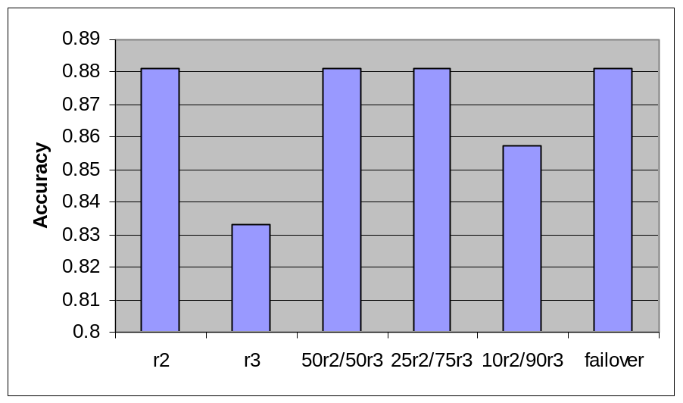

Summary of Code
Here is the description of the subdirectories:

terms/ | Contains files which list the existing search terms for each category. There are special files named test.terms and test.ans that contain the terms for the test set and correct categorization of those terms.
results/ | Contains the search results from Google for the search terms in each category
crawl/ | Contains the web pages downloaded for each category
words/ | Contains the words that have been parsed from each of the web pages
shingles/ | Contains the shingling of each web page. The shingle size is appended onto the end of the filenames.
termshingles/ | Contains the combined shingles for the categories and for each search term.
Text/ | Contains the Text::English open source library which I use for stemming

Here is a description of each file:

shingles.pl | Library used be almost all the scripts
Searchyahoo | Given a particular category, it will parse the search results from Yahoo/Google to the results/ directory and save all the web pages into the crawl/ directory.
parsehtml | Parses a web page into a sequence of words
all-parsehtml | Runs parsehtml on all pages in the crawl/ directory and saves the word sequences into the words/ directory
genshingles | Will create shingles of a particular size for a given word sequence file
all-genshingles | Runs genshingles on all word sequences in the words/ directory and saves the shingles to the shingles/.
gencategoryshingles | Combine the shingles from the web pages for each search term and for each category from shingles/ and saves them into termshingles/
gettopshingles | Reports the most commonly occurring shingles
categorize | Categorizes each of the search terms in the test set and reports on the accuracy.
runall | Wrapper script that runs everything

To run the entire system, execute the “runall” script. A complete run typically takes several hours.

Further Performance Improvements
There are several other possible approaches for further improving the performance of this classifier:

- Cluster related search terms in the corpus such as “las vegas”, “las vegas nevada” and “las vegas nv” so that either we calculate the resemblance against only a representative of the cluster or against the union of the entire cluster.
- Only store a representative subset of the shingles in each document as described by Manber [3].

Conclusions
We have seen that using the contents of the top web page matches as representations for search terms and calculating the resemblance of the shingling of the representations provides a good metric for determining the similarity of search terms. In practice, Yahoo would probably use this technique to provide automated guesses for the appropriate Inside Yahoo to display for each new search term. The editorial team would then choose among the guesses or manually override the results. Each choice made by the editorial team would then become part of the corpus and would contribute to improving future guesses.

Acknowledgements
I would like to thank Yahoo! for providing the inspiration and the data for this project, and to thank Professor Chris Manning for his suggestions on how to approach this problem. I would also like to thank the authors of the LWP::Simple and Text::English Perl open source modules which I employed in my implementation [5].

Representative Samples of Search Term Similarity

edmunds
- used cars
- usedcars
- kelley blue book
- used car prices
- used car values

aruba
- bermuda
- cayman islands
- bahamas
- georgia map
- jamaica

caesar palace
- yahoo travel
- las vegas nevada
- las vagas
- dollar car rental
- las vegas nv

tiger woods
- pga
- pga golf
- college basketball
- fantasy golf
- golf handicap tracker

mapblast
- maps driving directions
- driving directions
- maps usa
- map search
- directions

student jobs
- part time job
- part time employment
- part time jobs
- resume builder
- relocation calculator

love [*]
- relationships
- sex
- picture personals
- personals mailbox
- my personals

bmw [**]
- blue book cars
- car prices
- new car
- single
- love

Note that the system has learned that:

[*] Relationships are most important for love. Sex is only second best.
[**] Owning a BMW helps you find dates. Recall that the second algorithm classified
“bmw” as personals instead of autos.

References

[1] A. Broder, S. Glassman, M. Manasse, and G. Zweig. Syntactic Clustering of the Web. Proceedings of WWW6, 1997.

[2] T. Haveliwala, A. Gionis, D. Klein, P. Indyk. Evaluating Strategies for Similarity Search on the Web. Proceedings of WWW11, 2002.

[3] U. Manber. Finding Similar Files in a Large File System. Proceedings of the 1994 USENIX Conference, January 1994.

[4] M. Porter. An Algorithm for Suffix Stripping. Program: Automated Library and Information Systems, 14(3):130-137, 1980.

[5] CPAN. http://www.cpan.org/

