Frame aided Multiple Document Summarization
Anish J. Adukuzhiyil
Nuwan I. Senaratna
Stanford University

{ajohna, nuwans}@cs.stanford.edu

Abstract
A system that would automatically produce summaries of multiple document sets has many applications. The exponential increase in the amount of textual information produced today, particularly over the internet, has, in the last couple of years, accelerated research in this direction. Although there have been several advances in the state of the art, current methods are not without their drawbacks. In this project, we propose a novel and highly effective method for Multiple Document Summarization aided by the use of FrameNet frames. We use FrameNet, the Stanford POS Tagger and WordNet to enhance a conventional Multiple Document Summarization (MDS) pipeline. Our tests indicate that our method performs better than several current approaches. We also discuss how our method can be enhanced and extended.

Introduction
Consider the scenario of a human user browsing the internet for information on a particular news story. Assuming that the news story is sufficiently news-worthy and that our user needs a fairly detailed version of the story, she would probably have to read through dozens of news articles. Finding these articles is not too difficult. Typing a couple of keywords related to the topic on an internet search engine such has Google would instantly provide her with links to several news related websites having up-to-date articles on the topic. However, the chances are that many of these articles will have redundant information, since they would have been written independently. Conversely, one article might also have important details of the story not found in any other. Since these important details are important to our user, she will have no choice but to read through all the articles. Although many online news agencies do cluster links to similar news articles from different sources and present them to the user, she will still be forced to go through all the articles in order to obtain more details.

Similarly, consider the scenario of a University student doing a literature survey on some research topic he is new to. Typically, here again, he would do a web search on a few good keywords and then read through the abstracts and introductions of the research papers appearing highest up on the search. Usually, these papers might refer to each other, and many might have a lot of overlap in there descriptions of introductory material. However, they would have quite a lot of novel details as well. As in the scenario with the news articles, our student is forced to do a lot of extra reading.

The two scenarios described above are all too common. Given almost any topic of interest, particularly in the wake of the rise of the internet, the number of useful information sources has increased exponentially. Unfortunately, such sources are generally independent, and diverse in style, intended audience, reporting bias and level of detail. Both tasks described above demonstrate the need for robust systems that can synthesize similar information from diverse sources into coherent summaries. Although the scenarios described above are restricted to the case of a human user searching for a topic of interest, a satisfactory solution to the problem would have applications in many other areas of interest, including information extraction, retrieval and processing.

The “Summarization” problem
The application we describe can be generalized as the “Multi-document Summarization” problem, which is what we consider in this paper. While we are working specifically in the news-article domain, as we shall see, many of the insights we gain and techniques we develop are applicable to the problem in general.

There are several characteristics that a good document summarizing system should attempt to maximize. The difficulty of the problem could be viewed as the difficulty in achieving reasonably high levels of these characteristics:

1) Compression in presentation: Usually, there would be a limit on the length of the summary that the user desires. For example, the user might want a 100 word summary of all the news articles describing a particular news event. In some case, the size of the summary might be proportional to the number of input articles, while in others it might be dependent on the nature of the input articles. Eitherway, the compression level is usually an input parameter of the summarization system, and a reasonable system should be flexible in the level of compression it is capable of.

2) Preservation of semantic information: The system might have to categorize the content of the input so that information that is representative of dissimilar details is retained, while redundant information is sieved out.

3) Coherence of generated summaries: They should be syntactically correct and be grammatical. They must also follow a coherent order, easing comprehension.

Unfortunately, the above characteristics tend to conflict. For example, achieving a greater degree of compression comes at the cost of compromising the quality of semantic information preserved. Optimizing these first two characteristics often results in compromising the third.

What are the additional challenges found in Multi-document Summarization?
All the above characteristics apply to multi-document summarization as well. However, beyond achieving satisfactory levels in these, a Multi-document Summarization (MDS) system has additional challenges.

In a single document, the problem of compression is limited to recognizing what the most important information units are. However, in MDS, several different articles will contain the same or very similar examples of information units. Additionally, this repetition is often not clear-cut; for example, the information conveyed in one document in one sentence, might be conveyed via two sentences in another document. We need an effective method of recognizing these similarities, and methods of either merging or splitting information units.

Also, in MDS, different input documents might report the same story while emphasizing different parts of it. A good MDS system needs to be aware of this and come up with a good means of selecting and ordering the points of view to be represented in the summary.

Finally, MDS systems usually involve large sets of data, processing large numbers of sentences and compiling and comparing large amounts of statistics. Conversely, many applications of MDS require that all this processing is performed in a reasonable amount of time. Hence, it is also vital that MDS systems scale well and are based on efficient processing algorithms.

What are our motivations?
As we described in Section 1, there are many situations that can benefit greatly from a well-working solution to the problem of MDS. It is an exciting area to be working in, as any improvement over the status-quo solutions would be appreciated.

Attempts at MDS thus far can be categorized into three types: Methods based on information fusion, methods based on document clustering and methods based on sentence compression. In the next section we explore in some detail all these attempts that have helped extend the state of the art in MDS significantly. While these have resulted in new insights as how to approach the problem, as we shall also see, these approaches do have several drawbacks.

Upon investigating the attempts at MDS so far, we have observed the possibility of optimizing and extending certain aspects of these techniques. Also, we have identified better ways of representing the knowledge, and the relations between the knowledge, contained in the input documents – which would definitely ease the task of summarization. By augmenting a conventional MDS system pipeline with several of these extended and new components we believe that significant improvements over the current solutions can be obtained.

Prior Work
In general, the pipeline of an MDS system contains three processes: First, the input multiple documents are clustered into groups of sentences according to their information content. That is, sentences that have similar content are grouped into the same cluster. Second, these sentence clusters are used to generate some intermediate representation of the sentences that will encode the comparative usefulness of each sentence for the summarization process. Finally, the intermediate representation of sentences is used to generate the summary.

We now described three approaches to MDS which are representative of some of the fundamental techniques behind the current state of the art [Goldstein2000], [Ding2004], [Harabagiu2002], [Jing2001], [Masao2000].
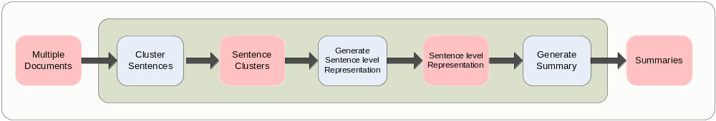
- Conventional MDS Pipeline

Information Fusion
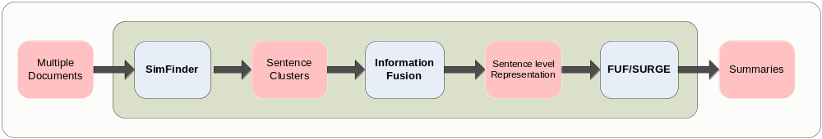
- Pipeline for Information Fusion

The first technique we describe is Information Fusion presented in [Barzilay2003]. We also refer [McKeown1999], [Barzilay1999], [Barzilay2004] and [Barzilay2005].

An information fusion based MDS system typically consists of two components: An analysis component (which corresponds to the “Cluster Sentences” stage in the general pipeline) and a fusion component (which corresponds to the “Generate Sentence level representation” stage).

The analysis component begins by identifying groups of sentence units from different input documents that contain similar or repeated information. These groups of sentence units are typically referred to as themes. A given set of input articles might contain several themes. The sentence units are grouped into themes using various statistics. These statistics might range from simple word statistics such as word counts to semantic sense overlap to more elaborate measures such as positional information relations between groups of words. This is implemented using SimFinder [Barzilay2003].

The real power of information fusion is due to the fusion component. This aims at combining the themes in order to create a coherent summary. This process of combination typically consists of two stages: Sentence fusion and sentence ordering.

In the sentence fusion stage, the grammatical structure of each sentence in a theme is analyzed and for each a predicate grammatical argument structure is derived. These argument structures are aligned to determine what information is most commonly shared between sentences in a particular theme. This common structure is known as a basis tree. A basis tree might be further augmented with material thought to be representative of the theme, and might also be pruned to remove non-representative material. Finally, a language model is used to convert the transformed basis tree back into a sentence.

In combining sentences to form a summary, the sentences must follow an acceptable order so that logical and chronological constraints are respected. In the sentence ordering stage, themes that are logically cohesive are first identified, usually using the word distribution of input articles. Finally, chronological constraints are enforced by ordering these logically coherent groups using the time-stamps of input articles. This is implemented using the existing techniques FUF and SURGE [Barzilay2003].

Sentence Compression based techniques
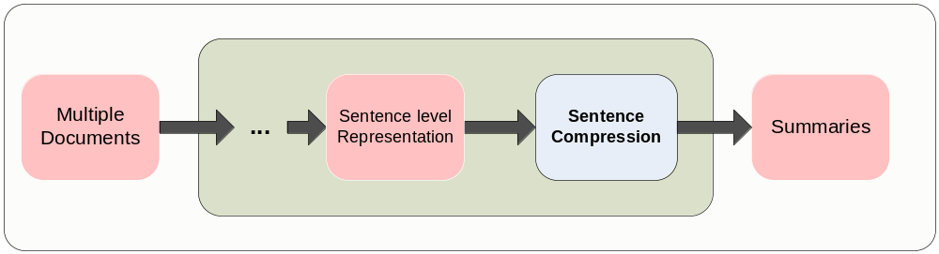
- Pipeline Segment for Sentence Compression
The second approach we describe is Sentence Compression. As example we give two sentence compression algorithms presented in [Knight2002]

Sentence compression consists of, given a long input sentence, converting it into a shorter sentence that retains as much of its information content. With respect to the general MDS pipeline, we can either consider sentence compression as the entire pipeline that takes in multiple document and outputs summaries, or conversely we can consider sentence compression as the final “Generate Summary” stage.

[Knight2002] introduce two different methods of sentence compression: The first based on a noisy-channel model, the second based on a decision based conditional model. Both methods take as input a parse tree derived from the sentence to be compressed, and output a smaller parse tree from which the compressed sentence can be reconstructed.

The noisy-channel model method is based on modeling the generation “long” sentences from “short” sentences. It uses a source model that models the probability of each “short” sentence, and a channel model that models the probability of generating a given “long” sentence from a given “short” sentence. The source model is a combination of a context-free grammar based model and a Bigram language model, while the channel model is based on a context-free grammar based model.

The decision based model is inspired by shift-reduce parsers. The compression of the parse tree consists of a sequence of operations consisting of shift, reduce, assign-type and drop together with an input list and stack. The sequence is determined by a statistical decision tree.

Document Cluster Centroid based techniques
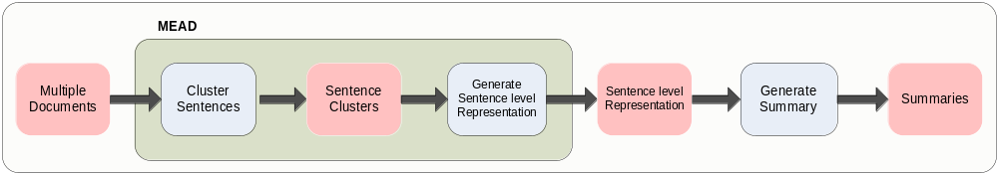
- Pipeline for MEAD

Finally we describe systems that use document cluster centroids such as the MEAD system described in [Radev2004]. We also refer to [Daniel2003].

Document clustering based techniques, cluster sets of input articles, and then for each cluster choose a subset of sentences from the input documents that might best form a representative summary of the cluster.

The MEAD system works as follows. First, using a centroid based clustering technique the input articles are clustered. MEAD uses TF-IDF (Term Frequency – Inverted Document Frequency) based centroid formulation. TF is a measure of the occurrence of a word in a cluster, while IDF is a measure of how “surprising” or “unexpected” a word is. Also, stop words are excluded from this representation. These operations correspond to the “Cluster Sentences” stage in the general MDS pipeline.

Second, for each cluster, the system selects potential summary sentences based on two criteria: Firstly, it considers the relative relevance of a particular sentence to the general topic; Secondly, it considers the degree to which a particular sentence repeats information conveyed in other sentences. The first criteria should be maximized, the second minimized. Sentences are assigned ranks based on these criteria by an iterative re-ranking algorithm. This approach is similar to Maximal Marginal Relevance (MMR) used in information retrieval [Goldstein1998]. These operations correspond to the “Generate Sentence Level Representation” stage in the general MDS pipeline.

Finally, as in information fusion, time-stamps are used to order sentences coherently. These operations correspond to the “Generate Summary” stage in the general MDS pipeline.

Certain drawbacks in these systems
Although the approaches described above represent significant progress in the state of the art, they do have certain drawbacks. We list some of these:

- The “Cluster Sentence” stage does not often result in sentence clusters that model the actual information content sufficiently accurately. For example, in the information fusion methods described, the “themes” generated are not always satisfactory. Often, similar sentences tend to fall into different themes, while a single theme would often contain extremely divergent sentences. Similarly, in the clustering based approach, TF-IDF based statistics do not always generate satisfactory clusters.

- The “Generate Sentence Level Representation” stage does not sufficiently consider inter-relationships between sentences. For example, the re-ranking technique used in the clustering approach solely employs a linear measure of the merit of each sentence, when in actual fact inter-relationships between sentences often result in a need for considering far more complex relationship measures between sentences.

- The “Generate Summary” stage does not consider global semantic relationships when constructing the summary. For example, in both the information fusion and clustering method described, the final summary is constructed by solely using the sentence representation generated in the previous stage and document time stamps. It does not consider possible dependencies between individual sentences in the ordering.

- All the approaches discussed do not contain measures for comparing information units that, though might contain different word forms, are semantically equivalent.

In our approach, which we describe next, we hope to address these issues as well as propose several novel approaches for extending performance.

Our Approach
Our approach is based on the conventional MDS pipeline described above. However, we propose several new strategies for implementing each stage.

- We implement the “Cluster Sentence” stage by relating each of the input sentences to FrameNet frames.

- We implement the “Generate Sentence Level Representation” stage by augmenting the sentence representation with several similarity statistics. We enhance existing statistical measures with several measures that incorporate additional semantic measurements based on WordNet.

- Finally, we implement the “Generate Summary” stage by combining conventional time-stamp ordering criteria along with the similarity measures we have computed in the previous stage.

Our choice of using FrameNet frames has several advantages over the approaches discussed above. First, very often it is very easy to relate a specific information detail to a frame. Hence then, frame population leads to an intuitive form of clustering. Secondly, since typically a single sentence might map to more than one frame, frame population allows a many-to-many relationship between the sentences and the cluster. This model is in far more representative of the real world. This also allows more flexible implementation options further down the pipeline.

A frame can be thought of as a concept with a script that can be used to define an object, state or event. Each frame is accompanied by a set of lexical units that are associated with the concept portrayed by the frame. It is possible to get an approximate idea of whether or not a given sentence conveys a frame concept by comparing its words to the lexical units of the frame. Hence, given an article, it is possible to analyze the distribution of the correspondence between the sentences in the article and the frames that relate to those sentences.

Our analysis of news articles showed that news articles pertaining to the same or similar topics tended to have similar frame distributions, while those with contrasting topics tended to have dissimilar frame distributions. For example in Figure 5 we have the frame distributions of the five most common frames overall (Commerce-sell, Employing, Economy, Military, Speed and Unemployment-rate) for 10 documents, each of which discuss the state of unemployment in Hong Kong and various measures the government is taking to reduce it. As is evident, all the documents in the cluster share the same frames as their most common frames, as the cluster taken as a whole.

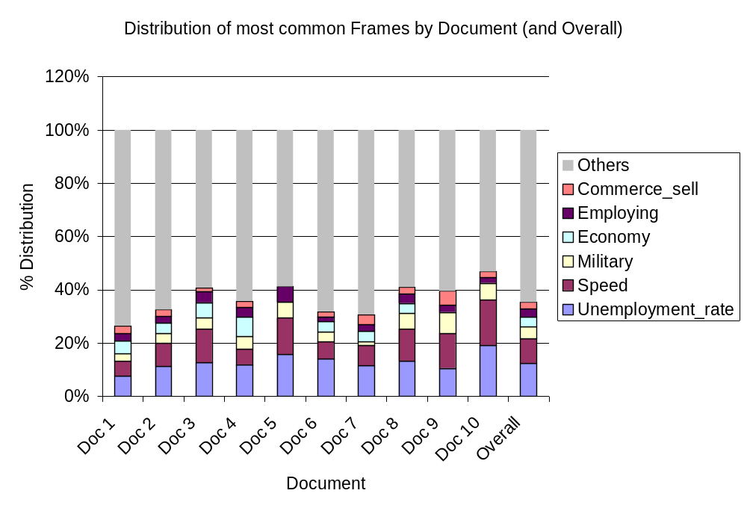
- Distribution of Most Common Frames by Document (and Overall)

Conversely, in Figure 6 we have the frame distributions for two contrasting collections of articles.

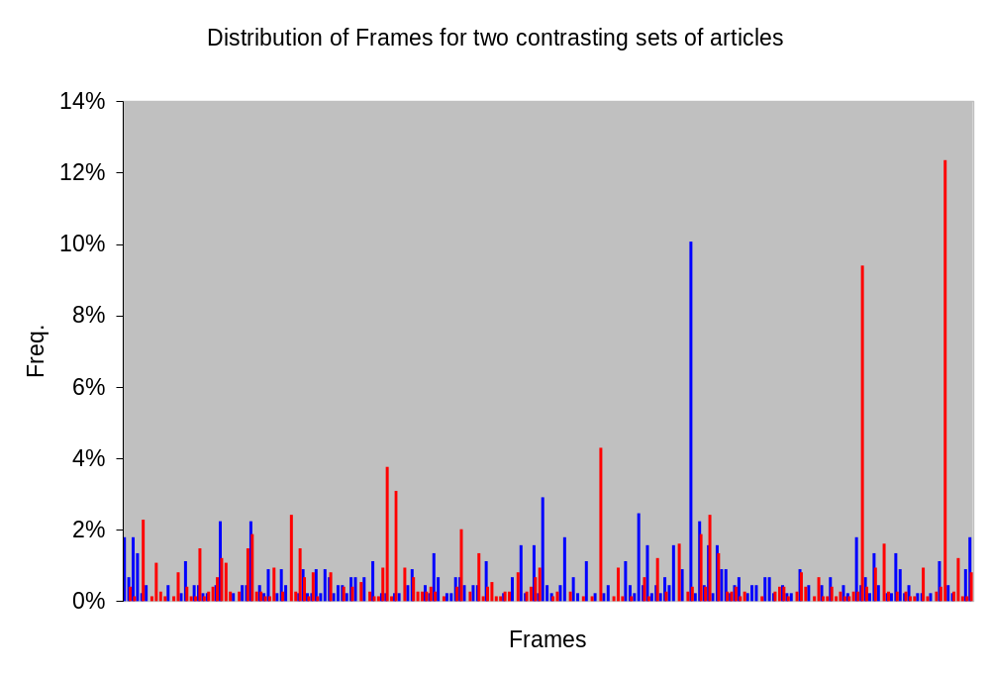
- Distribution of Frames for Two Contrasting Sets of Articles

The WordNet lexicon is a rich source of information of all kinds concerning word senses and synsets. Using the WordNet hierarchy explicitly in order to compute the similarity between two given word synsets allow the possibility of a certain kind of 'semantic' similarity matching, as the synsets in the WordNet hierarchy are definitely organized in order of similarity of concept. This is a step higher than any superficial word level similarity measure, which only takes in to account the surface form of the word used. For the purposes of comparing the sentences that populate a given frame, using a WordNet inspired semantic similarity measure can help correctly capture diverse sentences that nonetheless express similar concepts.

The “Big Picture”

A brief discussion of our method, with a high-level description of the implementation follows:

- From the SummBank corpus, a set of similarly-themed documents is selected.
- The documents are split into sentences and all the common words in each sentence are then lemmatized using WordNet.

- These sentences are then used to populate frames derived from the FrameNet database. This is done by using the lexical units given in FrameNet – words that are highly indicative of the frame in question. For example, the frame ‘Craft’, defined as “A particular Activity, performed conventionally or habitually by more than one Practitioner within a Culture, is described in terms of its method”, has the following lexical units: art#n, craft#n, science#n. Note that this is a many-to-many mapping, as a given sentence may belong to many frames, based on whether or not it contains their lexical units. Now each frame contains several sentences, each drawn from one of the documents in the set.
- For each frame, the pair-wise inter-sentence similarities between the set of sentences it contains is calculated. Here we tried several semantic similarity measures derived from the WordNet database, as discussed in [Evans2005], [Gurevych2004], [Jiang1997], [Lin1998] and [Leacock1998].

- Having computed the sentence-by-sentences similarity measures for each frame, we use these statistics to reduce the sentences into an intermediate representation that would enable us to perform the final summarization. We do this by hierarchically clustering the sentences within each frame according to the similarity measures. Clustering thus ensures that within each frame, sentences that are highly semantically similar get clubbed together.
- Once the sentences within each frame have been clustered, we proceeded to generate the summary by selecting sentences from these clusters. A sentence is selected based on its relevance compared to the entire document set’s frame instantiation pattern, the extra information it contains as compared to the others in its cluster, and the summary length limits posed by the user.

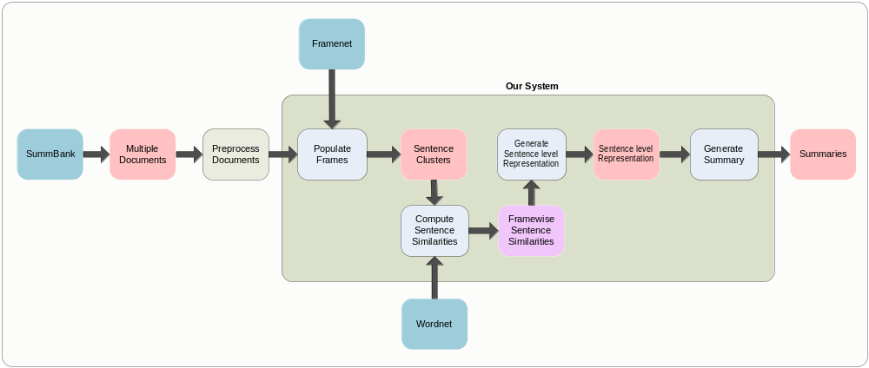
- Pipeline for Our Approach

What previous work/ software libraries we propose to build upon
In this section we describe each of the above steps in greater detail, as well as discuss some of the issues we faced in the implementation and how we resolved these.

SummBank 1.0 corpus
This corpus, made available to us as part of the LDC corpora, contains the data created for the Summer 2001 Johns Hopkins Workshop which focused on text summarization in a cross-lingual information retrieval framework. The goal of the corpus is to gather together a corpus of original documents and summaries which can be used as gold standards by the documents summarization community.

It contains 40 news clusters in English and Chinese, 360 multi-document, human-written non-extractive summaries, and nearly two million single document and multi-document extracts created by automatic and manual methods. The automatic summarizer used is called MEAD – we compare our final summary outputs to the extracts generated by MEAD for the same input.

Lemmatization
We used the WordNet::QueryData Perl package in conjunction with a Porter stemming package and Text::Levenshtein, a string edit distance computation package. QueryData allowed access the WordNet lexicon, and for each word, the porter-stemmed form was mapped to the closest derivable lemma in terms of edit distance.

Frame population
We accessed the FrameNet database using the FrameNet 1.3 Java API developed by Nils Reiter [Fillmore 2000]. We initially used all the 721 frames that are available in the FrameNet database, but some analysis of the populated frames revealed that quite a few of the frames are rather general in nature, and hence attract a large number of sentences. However, these frames could be removed from consideration without affecting the later stages to any perceptible degree.

We identified these frames by taking as input all the 40 document clusters for the frame population stage. We evaluated the frame-uniformity or “generic-ness” 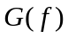 of a frame  by computing the following entropy like statistic: 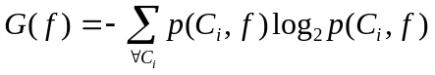 where 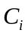is a document cluster and 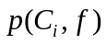 is the proportion of sentence-frame pairs in that correspond to frame.

Our intuition that the most general frames would naturally be the frames containing the largest number of sentences was borne true. The frames with the ten highest were Calendric_unit, Cardinal_numbers, Taking_sides, Locative_relation, Topic, Being_in_operation, Origin, Time_vector, Measure_duration and Partitive. We also noticed that the relationship between the Frame Uniformity and the number of sentences corresponding to the frame is exponential (Figure 8). The red line in Figure 8 corresponds to the threshold where we removed frames.
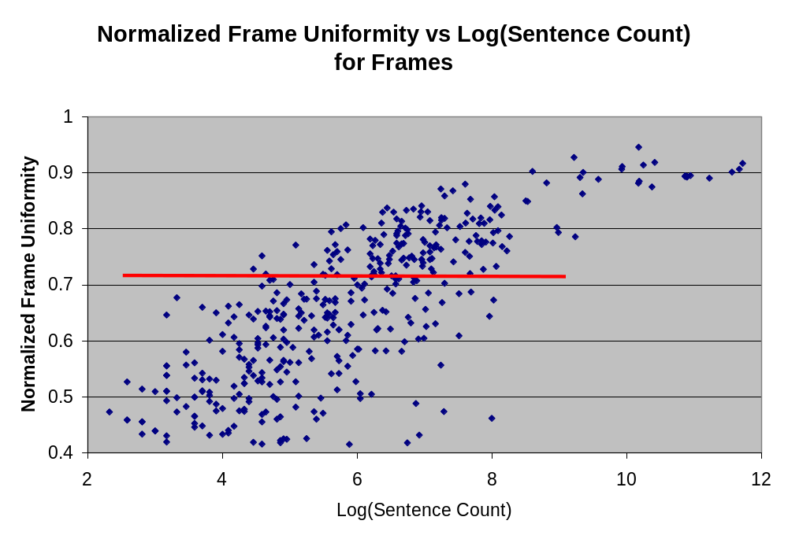
- Normalized Frame Uniformity vs. Log (Sentence Count) for Frames
Further, we also clustered the remaining frames, on basis of a similarity measure derived from the sentences they contained. This was done in order to bring together frames that are very similar in terms of their constituents, so that redundancy in knowledge representation can be removed.
The similarity measure between two frames A and B,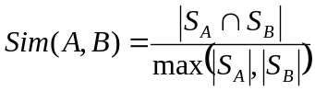, where 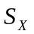 is the number of sentences in frame .

Intra-frame pair-wise sentence similarity computation
We use the WordNet::Similarity package, which uses the WordNet corpus in order to implement several similarity measures. In particular, it supports the measures of [Resnik1995], [Lin1998], [Jiang1997], [Leacock1998], [Hirst1998], [Wu1994] and [Pedersen2002]. Rather than using these directly, there were a few other things we had to take care first:

POS tagging
Since all the WordNet::Similarity algorithms require a word sense as input, we had to determine the best possible POS of the word under consideration, as could be determined from context. We used the Stanford POS tagger [Toutanova2000] to do this. This also allowed us to filter out words that were not Nouns, Verbs, Adjectives or Adverbs, which are the only classes of English words present in WordNet. This is beneficial to us, as this reduces false boosts to inter-sentence similarities from matching of non-content words like function words etc.

Extended gloss overlap algorithm
One of the algorithms implemented by WordNet::Similarity, this takes as input two concepts (represented by two WordNet synsets) and outputs a numeric value that quantifies their degree of semantic relatedness. We settled on this as our choice for semantic similarity, as it was the only one which allowed us to compare two words from different parts of speech, which we felt was important (allowing comparison between ‘cycle’ and ‘biked’, for example).

When measuring the relatedness between two input synsets, it not only looks for overlaps between the glosses of those synsets, but also between the glosses of the hypernym, hyponym, meronym, holonym and troponym synsets of the input synsets, as well as between synsets related to the input synsets through the relations of attribute, similar–to and also–see.

The exact equation is:
Where A, B = WordNet synsets
hypo(A) = hyponyms of A
hype(A) = hypernyms of A
score(X,Y) = score based on level of word and phrase level overlap between X and Y

More details about the scoring mechanism can be obtained in [Banerjee2003].
Inter sentence similarity
Since this package only calculates similarities between two specified word senses, we had to derive a scheme to compute similarities between two sentences based on the similarities of their constituent words:

Given two sentences, we try to find the best match for all the words in the smaller sentence from among the words making up the longer sentence. The pseudo-code for the algorithm is given below:

for each sentence pair (s1, s2) in a given frame f, where s1 is longer than s2:
word_list1 = words in s1 not included in lexical unit list for frame f
word_list2 = words in s2 not included in lexical unit list for frame f
for each word in word_list1
{
for each word in word_list 2
{
matrix M(w1, w2) = similarity(first WordNet sense of word w1, first WordNet sense of word w2)
}
}
similarity(s1, s2) = optimal solution to assignment problem given matrix M, divided by length of the longer word list, i.e. word_list2
First, a semantic similarity value is computed for all pair wise word combinations from both sentences, choosing the first WordNet sense for both. If one or both of the words are not present in WordNet, a similarity score is obtained using the inverse of the edit distance, multiplied by a constant. Then a terminating auction based allocation algorithm[Bertsekas1979] is used to solve the assignment problem, where each word from the smaller sentence was assigned to exactly one word from the longer one, so that the sum of the semantic similarities of the assigned pairs is maximized. This sum, divided by the length of the longer sentence, was used as the similarity score for the given sentence pair.

Optimizations
The actual sentence level semantic similarity calculations using the WordNet:Similarity module is somewhat time-consuming, especially considering that to compute similarities between two sentences n and m words long each, order(nm) calls to the WordNet::Similarity module. In a bid to reduce the average number of module calls, we cut the number of sentences actually compared to each other in a frame to only those from different article sources. For purposes of summarization of a document, we identified that there usually would be no redundancy in a single document, and hence comparison of similarity between two sentences from the same article is not of much use from the point of view of cluster formation.

Intra-frame sentence clustering
Once the pair-wise sentence similarity scores are calculated, we ran standard hierarchical clustering as follows:
For each frame {
Initialize set of clusters, so that each cluster contains one sentence (and we
have a cluster for each sentence)

While sentences can be clustered further*{
Find the two most similar clusters**.
Merge the two most similar clusters.
}
}

We evaluate the similarity between clusters (**) as the mean pairwise sentence-by-sentences similarity between each of the sentences in one sentence with each of the sentences in the other sentences. In the trivial case where each cluster has only one sentence, the similarity measure is identical to the sentence-by-sentences similarity measure.

We evaluate whether clusters “sentences can be clustered further” (*) as follows: We find the maximum similarity measure observed in all previous iterations (of the “While” loop) thus far, global_maximumSimilarity. If the maximum similarity between the most similar clusters in the current iteration is less than *global_maximumSimilarity where 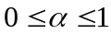 (typically around 0.5), we conclude that the clustering is sufficient. In addition, if the maximum similarity in the current iteration is less than some constant threshold we similarly terminate the clustering.

Each frame corresponds to some distinct topic of information relevant to the total information content in the input multiple documents. After the within frame clustering, each cluster will contain sentences stating similar information about each topic.

Summary generation
Sentence selection
Once we have clustered the sentences within each frame, we populate the summary in a “round-robin” fashion as follows.
Sort all sentences in decreasing order of importance*

Initialize a summary sentence set (that would contain all the sentences that would make up the summary) to an empty sent

While sentences in the sentence set does not have enough words to make up the required summary**{
For each frame (in sorted importance order){
For each sentence cluster within the frame{
If the sentence cluster has sufficient documents***{
Find the most representative sentence in the sentence cluster
If the sentence is not already in the summary sentence set{
Add it to the summary sentence set
}
}
}
}
}
We define one frame as being more “important” (*) than another frame according to three criteria.
A frame, X is more important than another frame Y iff,
- X contains sentences from a larger number of documents than Y
- OR X and Y are equal on condition 1 AND X contains more sentences than Y
- OR X and Y are equal on both conditions 1 and 2 and X has less variance in the classes of documents it has compared to Y. (That is, X tends to have more sentences from a fewer set of documents compared to Y. We compute this as an entropy based on the probability of a sentence in a frame being from a given document)

Condition 1 enforces the fact that the frame should be globally representative of all the input multiple documents. Given that two frames are equally representative of the input, condition 2 enforces the fact that the frame should contain more information. Finally, give that two frames are equal on conditions 1 and 2, condition 3 enforces that a frame contains data more specific to a particular topic. Although, condition 3 might seem contradictory to condition 1, it becomes a valid measure since both frames compared are equal on condition 1.

The size of the required summary (**) is specified by the user, either as an absolute value (e.g. 50, 100 or 200 words) or as a proportion of the total number of words in the input set of multiple documents.

In checking for whether a cluster has “sufficient documents”, we check if it contains sentences from at least some proportion of the number of documents. At each iteration (of the “While” loop) this proportion is diminished.

Sentence ordering
Once, we have the summary set of sentences, we order them according to:
1) The time-stamp of the document in which they appeared
2) The position of the sentence in its original document, normalized by the length of the document.

How do we propose to test/evaluate the system?
It cannot be denied that the best judge of the quality of any text intended for human readers would be just such a reader, as the worth of such is directly related to user expectations and usage patterns. For robustness of the evaluation, it would be better to get several human experts to look at the text and evaluate independently, using the points of greatest agreement as final means of evaluation.

Since in essence our system is an extractive summarization system, this task could be modified by having humans actually rate sentences from the original documents as relevant or not to a summary. This allows us to quantitatively evaluate the quality of our system, looking at whether the sentences selected by the system for purposes of the summary are also rated highly by humans. This also enables direct comparison of our results with other automatic extractive summarization systems.

We compared our summaries with the summaries produced by MEAD. We performed comparisons using two tests: In our first test, we evaluated the importance of each sentence in the test documents by carrying out a user study and asking the users to score the sentences on a scale of 1 to 3 based on relevance. We then normalized the user scores and computed the normalized relevance scores of the sentences in our summaries. In our second test, we performed the same test, but instead of the user scores, we used a set of judge assigned utilities for the sentences that was provided as a part of SummBank.

Discussion of Results

Analysis of Frame Population
The idea of using frames as a means for clustering sentences is definitely justified in view of the strong validation for the argument of unique frame distribution distinguishing news-stories, as given in Section 3. For example, cluster 827 talks about participation invited and encouraged for a health education program in Hong-Kong schools. In our model, the frame that has among the largest number of instantiation is 'Medical conditions', which clearly fits the bill.

The use of lexical units for populating frames is not exactly foolproof - there are many cases where the senses of lexical units used in two sentences are different, but they are still put in the same frame. For example, consider the following sentence pair:

S#1: The Spokesman said: “Students who have completed the programme will be issued a Certificate of Award.”

S#2: Held for the fifth year, this year's Competition has attracted more than 350 written projects on 'Public health is a public concern' submitted by some 100 schools throughout the territory.

These two are put in the “Point_of_dispute” frame, which is defined in the FrameNet database as involving: “The answer to a Question is under discussion in a Group, which still has a difference of opinion among its members. The prominence of the Question relative to others can be indicated by a Status expression.” Clearly, S#2 contains an instance of this frame, while the same cannot be claimed of S#1. However, both are put in the “Point_of_dispute” frame in this case as while the first contains lexical unit 'issue' in some form, the latter contains 'concern'. Clearly a robust WSD module would help improve the frame population accuracy rate.

Analysis of Sentence Similarity Computation
The similarity measure employed certainly captures very obvious equivalents, but also quite a few subtle ones. Consider these two sentences in the 'Departing' frame:

S#1: The top 24 students emerging from the Competition will be appointed as “PUC Ambassadors of Hygiene” and awarded a free study-cum-pleasure trip to Japan during the Easter holidays in April next year .

S#2: A group of 24 Provisional Urban Council Ambassadors of Hygiene departed for Japan today (Tuesday) with a special mission of exchanging views and experiences with Japanese officials and students on environmental and food hygiene.

These two sentences do not in fact share many n-gram sequences, but our approach correctly clusters these two together. However, a clever key word based clustering scheme may also be able to do this successfully.

Upon further analysis of the actual sentences, it appears that extrapolating a sentence similarity score from word level similarities is not entirely correct. For example, consider these sentences in the Returning frame:

S#1: Mr Tung will return to Hong Kong on the evening of June 19.

S#2: Mr Tung will return to Hong Kong in the evening of September 14.

Clearly, the two are talking about two separate occasions, but the WordNet based similarity computation method does not differentiate much between June and September - both are somewhat close in the WordNet hierarchy, both being months of the year. More importantly, the facts that the one sentence talks about a return in June, while the other talks about a return in September, both indicating mutual disagreement in details, are not used to decrease the similarity score otherwise calculated for the two sentences.

Analysis of Summary Generation
The choice of clustering threshold has been guided by heuristics developed after some data analysis, and there are some frames where this approach results in some fallacious results. For example, the semantic similarity computed between the two sentences discussed in Section 3.2.4. just exceeds the clustering threshold set at 50, and hence are put in the same cluster. The measure implemented in intra-frame clustering requiring that for merging to continue, the cluster similarity exceed a certain percentage of the maximum similarity value within the frame was developed to catch precisely such examples, but clearly it can do with some more tweaking.

We believe that our decision process guiding choice of the next sentence for the summary is very reasonable, and results in highly informative additions to the summary. For example, in cluster 827, our scheme for generating the summary by beginning with the frame with best article representation leads to choice of Medical conditions. Then we choose the cluster in this frame with best document representation, which picks one which has sentences from four different articles. Finally, our preference for sentences that contain the most proper noun sequences leads us to choosing the sentence: Organized by the Provisional Regional Council in association with the Education Department, the activity is a new health education programme aimed at encouraging students to make good use of their environmental hygiene facilities and service, and then disseminate the message to their schoolmates, friends and family

Clearly, at least in this case, the decision process leads to quality results. However, as can be seen in this case as well, the final criterion in picking a sentence from a selected cluster does often lead to preference for longer sentences.

Analysis of human tests
In our first test, we obtained user agreement kappa values between 15% and 20%. This was much higher than the kappa values for the SummBank judge utilities that were typically around 0%.

Due to time constraints we performed the first test on only one cluster (827). We obtained an average normalized relevance score of 0.52 for our system, while the MEAD summaries got 0.19.

For our second test, for most of the clusters, our system score higher normalized relevance scores than the MEAD summaries. However, given that the size of the test sets are relatively small, these statistics might not be significant.

System /Cluster | 2 | 46 | 54 | 60 | 61 | 62 | 447 | 827 | 885 | 1018
Our Relevance Score | 0.18 | 0.44 | 0.27 | 0.23 | 0.34 | 0.25 | 0.41 | 0.30 | 0.12 | 0.39
MEAD Relevance Score | 0.15 | 0.32 | 0.35 | 0.21 | 0.19 | 0.21 | 0.21 | 0.26 | 0.11 | 0.21
- Normalized Relevance Scores

Conclusion
To our knowledge, our work is the first to use the frames as an aid to clustering sentences in documents according to their themes. Also, we use a semantic similarity measure between sentences, derived from the WordNet lexicon. This is a significant move away from the purely statistical models of sentence similarity, as used in MEAD [Radev2004], based on keyword usage and statistics. As our experiments show, the results obtained by using such measures of similarity are very competitive with the statistical measures.

Through its successful integration of several already available NLP toolkits, our work is a ready example showing that the whole can be much more than the sum of its parts.

When looking at the main system pipeline as described in Section 3, we can readily think of a few components to improve upon:

Frame population
Instead of the frame clustering scheme currently employed, it would be interesting to use the FrameNet hierarchy itself in order to determine the best fit to a news-story theme from among the frame possibilities at various levels. Also, as discussed in Section 4.??, using lexical units as the criteria for populating frames is not a foolproof technique - some more clever checking may be in order here.

Sentence similarity computation
We can try out further refinements in the sentence similarity computation method, as it is very relevant to the subsequent clustering stage. While we only used the Extended Gloss based method from the WordNet, based on our intuition as explained in Section 3.2.4, it would be interesting to try the other similarity measures supported by the WordNet::Similarity package - though as this would constrain the matching to words with the same part-of-speech tag only, it may reduce the space of possible semantic matches considered. However, some of these (like the Jiang-Conrath [Jiang1997], Resnik measures [Resnik1995]) also incorporate Information Content values, which help account for the relative frequency differences in usage of WordNet concepts. For the same reason, it would be interesting to try to combine the current Extended Gloss based approach with the TF-IDF based similarity calculation scheme, in order to obtain sentence similarity scores which take into account the relative significance of the constituent words themselves.

Sentence clustering
While we tweaked the various parameters used in the hierarchical clustering method by incremental trial-and-error, making use of supervised training corpora here would certainly help obtain better parameter choices. While the human expert ratings provided along with the SummBank corpus are not exactly gold standard, training on some of this data would help justify choice of some of the parameter values, like clustering threshold etc, which are currently determined by small-scale testing and inspection alone.

Summary generation
Again, this is another part of the pipeline that currently employs many heuristics. Using the training data in order to maximize closeness to the judges' ratings would definitely help design better heuristics.

There are a few other things that we believe are reasonable next steps to carry out.

Optimization for speed
As it exists currently, the entire pipeline has two bottlenecks - at the frame population stage, and as explained in Section 3.2.3., the sentence similarity computation stage. Currently both of these stages take up about 20-25 minutes of time altogether for data equivalent to a single document cluster. Identifying and implementing possible speedups would help bring this system closer to real time in running, which would make the approach more amenable to online implementation.

Exploration of frame-based clustering techniques
Bringing the system online would bring to the fore issues related to the sourcing of same-story document clusters. Given the system reliance on the unique frame distribution pattern referred to in Section 3, it is imperative that the obtained document cluster be well defined and has high internal semantic and contextual similarity. Current document clustering techniques do not exhibit such precise behavior; as our system demonstrates, using frames certainly help better ensure that clustered sentences are similar in such regard. As such, it would be worthwhile to explore frame-based clustering techniques as well. One of us had already worked on such a clustering model as a course project here at Stanford - part of the code base has been based off this work.

Component Integration
As we mentioned, in this project we enhance the conventional MDS pipeline by augmenting several of its stages. Hence, this also allows us to “plug in” our model components into other existing systems. For example, we can use our sentence clustering mechanism to enhance the theme building process in the information fusion technique. We can also use our techniques as the initial steps in a sentence compression based technique. Finally, although we have implemented our system thus far as an extractive summarization system, the initial stages of our approach can be utilized equally well in an abstractive summarization technique.

Further Testing
Due to time constraints we were not able to evaluate the system with significantly large tests. Further tests are necessary to properly validate the merits of the system.

Acknowledgements
We would like to thank Nils Reiter for developing the FrameNet Java API and Julien Wetterwald for building upon it some of the code that we used in our initial prototypes. We would like to thank Anubha Kothari for helping us in getting access to much of our training and test data. Also, we would like to thank the many people who participated in our user survey. Last but not least, we would like to thank Prof. Christopher Manning for his invaluable advice, help and guidance.

References
[Banerjee2003] | S. Banerjee and T. Pedersen, "Extended gloss overlap as a measure of semantic relatedness", In Proceedings of the 18th International Joint Conference on Artificial Intelligence, Acapulco, Mexico, 2003
[Barzilay1999] | R. Barzilay, K. R. McKeown, and M. Elhadad, "Information fusion in the context of multi-document summarization", Proceedings of the 37th Association for Computational Linguistics, Maryland, 1999
[Barzilay2003] | R. Barzilay, "Information fusion for multi-document summarization: paraphrasing and generation,", PhD Thesis, Columbia University, 2003
[Barzilay2004] | R. Barzilay and L. Lee., "Catching the drift: probabilistic content models, with applications to generation and summarization", In Proceedings of NAACL-HLT, 2004
[Barzilay2005] | R. Barzilay and K. R. McKeown, "Sentence Fusion for Multi-document News Summarization", Computational Linguistics, MIT Press., 2005
[Bertsekas1979] | D. P. Bertsekas, "A Distributed Algorithm for the Assignment Problem", Information and Decision Systems Working Paper, MIT Press., 1979
[Daniel2003] | N. Daniel, D. Radev and T. Allison, "Sub-event based multi-document summarization", Proceedings of the HLT-NAACL 03 on Text summarization workshop, 2003
[Ding2004] | Y. Ding, "A Survey on Multi-Document Summarization", Department of Computer and Information Science University of Pennsylvania, 2004
[Evans2005] | D. K. Evans, "Identifying Similarity in Text: Multi-Lingual Analysis for Summarization", PhD Thesis, Columbia University, 2005
[Fillmore 2000] | C. J. Fillmore and C. F. Baker, "FrameNet: Frame semantics meets the corpus", In Proceedings of the 74th Annual Meeting of the Linguistic Society of America, 2000
[Goldstein1998] | J. Goldstein and J. Carbonell, "The use of MMR, diversity-based re-ranking for reordering documents and producing summaries", Proceedings of the 21st annual international ACM SIGIR conference on Research and development in information retrieval, 1998
[Goldstein2000] | J. Goldstein, V. Mittal, J. Carbonell and M. Kantrowitzt, "Multi-Document Summarization By Sentence Extraction", NAACL-ANLP 2000 Workshop on Automatic summarization, 2000
[Gurevych2004] | I. Gurevych and M. Strube, "Semantic Similarity Applied to Spoken Dialogue Summarization", Proceedings of the 20th international conference on Computational Linguistics, 2004
[Harabagiu2002] | S. M. Harabagiu , S. J. Maiorano, "Multi-Document Summarization with GISTEXTER", Proceedings of the workshop on automatic summarization, Philadelphia, Pennsylvania, 2002
[Hirst1998] | G. Hirst and D. St-Onge, “Lexical Chains as representations of context for the detection and correction of malapropisms”, In Fellbaum, 1998
[Jiang1997] | Jiang, J. J. and D. W. Conrath,, "Semantic similarity based on corpus statistics and lexical taxonomy", In Proceedings of the 10th International Conference on Research in Computational Linguistics, 1997
[Jing2001] | H. Jing, "Cut-and-Paste Text Summarization", PhD Thesis, Columbia University, 2001
[Knight2002] | K. Knight and D. Marcu, " Summarization beyond sentence extraction: A Probabilistic Approach to Sentence Compression ", Artificial Intelligence, 2002
[Leacock1998] | C. Leacock and M. Chodorow, "Combining local context and WordNet similarity for word sense identification", WordNet: An Electronic Lexical Database, MIT Press., 1998
[Lin1998] | D. Lin, "An information-theoretic definition of similarity", In Proceedings of the 15th International Conference on Machine Learning, 1998
[Masao2000] | U. Masao and H. Koiti, "Multi-Topic Multi-Document Summarization", Proceedings of COLING, 2000
[McKeown1999] | K. McKeown, J. Klavans, V. Hatzivassiloglou, R. Barzilay and E. Eskin, "Towards multidocument summarization by reformulation: progress and prospects", Proceedings of AAAI, 1999
[Pedersen2002] | T. Pedersen, "Semantic Similarity Package", http://www.d.umn.edu/~tpederse/similarity.html, 2002
[Radev2004] | D. R. Radev, H. Jing, M. Stys, and D. Tam, "Centroid-based summarization of multiple documents.", Information Processing and Management, 2004
[Resnik1995] | P. Resnik, "Using information content to evaluate semantic similarity in a taxonomy", In Proceedings of the 14th International Joint Conference on Artificial Intelligence, Montreal, Canada, 1995
[Toutanova2000] | K. Toutanova and C. D. Manning, "Enriching the Knowledge Sources Used in a Maximum Entropy Part-of-Speech Tagger", In Proceedings of the Joint SIGDAT Conference on Empirical Methods in Natural Language Processing and Very Large Corpora, 2000
[Wu1994] | Z. Wu and M.Palmer, “Verb Semantics and Lexical Selection”, In Proceedings of the 32nd Annual Meeting of the Association for Computational Linguistics. Las Cruces, New Mexico, 1994

