Language and Statistics
Spring 2006
Detecting Fake from Real Article

Amr Ahmed, Mengqiu Wang, Yi Wu

1. Introduction

The goal of this project is to discriminate between real broadcast news articles and fake ones where the fake ones where generated from a 3-gram language model trained over a 100MW corpus similar to the one from which the real articles were drawn. Articles, both fake and real, are of different lengths, and our task was to build a model that will be able to classify any new article as either fake or real and gives a probability of its decision. The input to our system was: i) a training set of 1000 articles (500 fake and 500 real). ii) 200 articles (100 real, 100 fake) to be used as development set to test/tune our mode. iii) Access to the 100MW broadcast news corpus. And iv) Access to the 3-gram model used to generate the fake articles. The performance is measured using both hard measure (accuracy of our decision) and soft measure (perplexity of correct label under our model).

In the rest of this document, we will describe our approach for this problem that leverages semantic, syntactic, lexical as well as distributional approaches to this problem. Using our approach, our performance on the development set was a hard measure of 90% and a soft measure of -0.28.

2. Overview of the approach

At a first glance our task seems to be trivial as we, human, can easily and effortlessly achieve near 100% accuracy for this task. However, it is these problems that human are good at, that machines can't do quite well. To that extent, we tried to use our linguistic/statistical training to formalize what we consider to be a second nature. The basic architecture of our system is detailed in Figure 1 below.

As depicted below, we tried to formalize what the 3-gram model can't model. Basically the 3-gram model can model local phenomenon very well, but it lacks a global view hence we tried to leverage the following features: Semantic, syntactical and lexical ones and we tried also to get the best out of them by deploying sound statistical techniques using feature selections and distributional adjustment ideas as we will detail on the next sections.

BN
corpus
Fake
corpus
Training
Data
Distributional Adjustment
Adjusted Training
Model

Develop-ment

3-gram LM
Feature Generation Module

Semantic Lexica Syntactic

Feature Selection Module
Parser
Tagers
SLM
NSP
Stemmer

R

LIBSVM

Figure 1

3 Adjusting the Input Distribution

A crucial assumption made by most if not all learning algorithms, is that testing and training data will be drawn from the same distribution; an assumption which is always violated by most, if not all, NLP problems in real life. However, in this problem we have access to some aspects (article length) of the distribution from which the test set will be drawn and we tried to leverage it to shape the training data. We tried to partition the input articles in a way that will keep the length distribution matched with those of the testing set. We employed a simple sampling scheme that operate as follows: for each article in the input set we sample an article length according to the distribution of the testing set, and then we trim the article based on this length; we then recursively repeat this process on the reminder of the trimmed article (keeping its label the same). If the sampled length is greater than the article length, we resample a new length. (we implemented a variant of this idea that avoid re-sampling) This algorithm is guaranteed to terminate since we have length one with probability 0.2. Using this approach we transformed the input article from 1000 (500 positive, 500 negative) into 9273 articles (4599 positives and 4674 negatives) with following length distribution shown in table 1.

The final input distribution matches that of the testing distribution. It should be noted that it was not our aim to overfit the development set but rather we were seeking to have a matched distribution so that we can say something with confidence about our performance on future data set. Particularly, our cross-validation (CV) score on this new input set should be an unbiased estimated to the true risk of our model under the correct distribution from which the data were generated. So optimizing on this new data would help us generalize better rather than fitting the data at hand! We were able to prove that experimentally, using only semantic features, we achieved 97% CV score on the old input data and only 74% on the test set, while using the new data we got around 77% CV-score on the new input set which is a better estimate of our true risk on the unseen data.

Table 1: The new training set
Length | Training |  | Testing |  | Percentage
 | Fake | Real | Fake | Real | Percentage
1 | 927 | 940 | 20 | 20 | 0.2
2 | 459 | 467 | 10 | 10 | 0.1
3 | 459 | 466 | 10 | 10 | 0.1
4 | 459 | 467 | 10 | 10 | 0.1
5 | 459 | 466 | 10 | 10 | 0.1
7 | 459 | 467 | 10 | 10 | 0.1
10 | 459 | 467 | 10 | 10 | 0.1
15 | 459 | 467 | 10 | 10 | 0.1
20 | 459 | 467 | 10 | 10 | 0.1

4 Feature Generation
In this section we detail our features, we can classify them into semantic, syntactical and lexical ones. All of them aim to spot deficiencies of the 3-gram model which are:

- Lack of global context and coherence.
- Lack of global statistics.
- Lack of syntax.
- Lack of fairness for rare events!

To do that we used the given 3-gram model and generated a new fake corpus comparable in size to the 100MW real one and we then feed both of them to the various feature generation modules. All of our features are article based ones, even if the feature is sentence based, we map it to article level using aggregation in the form of: weighted sum, maximum or minimum over all sentences on the article.

4.1 Lexical Features

The goal of these set of features is to come with measures that would disagree with the model used to generate the fake articles. We can decompose those features into those that depend on perplexity scores of various models and those that rely of N-gram based statistics.

4.1.1 Perplexity Feature:

Here, we also use the perplexity of the article under several language models as feature.
We have investigated the following:
- 1~5-gram models built on the part of speech on the 100M broadcast news.
- 1~5-gram model on the part of speech of the fake corpus we generated.
- 1~3 gram model on the 100Mbroad cast news words.

The following graphs show the distribution of the feature on fake and real articles: The following is the perplexity distribution of the unigram bigram and trigram on 100M text.
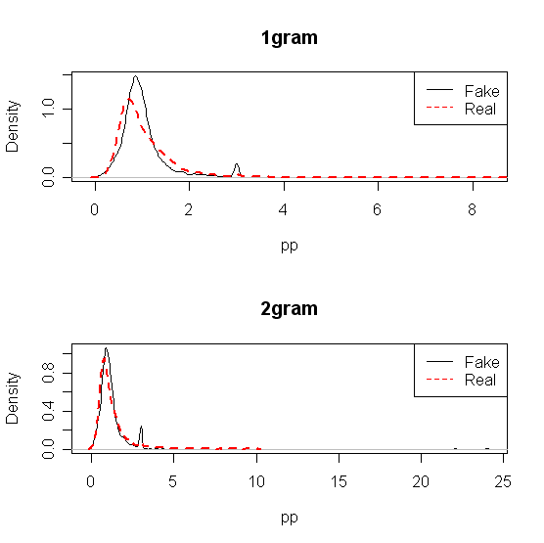
Below is the perplexity of the 1~5-gram model on the POS of the fake sentence
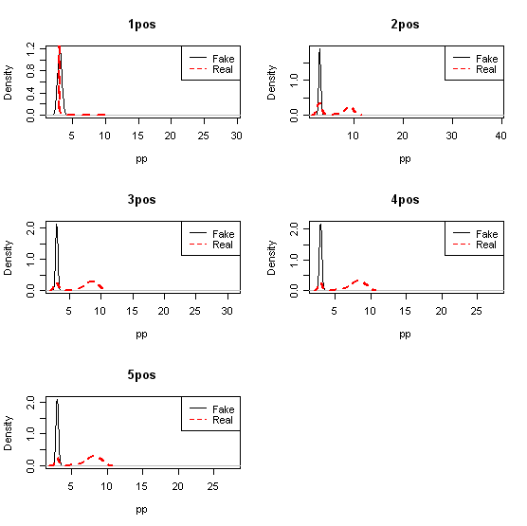
Below is the perplexity of the 1~5 gram model on the POS of the 100MW corpus
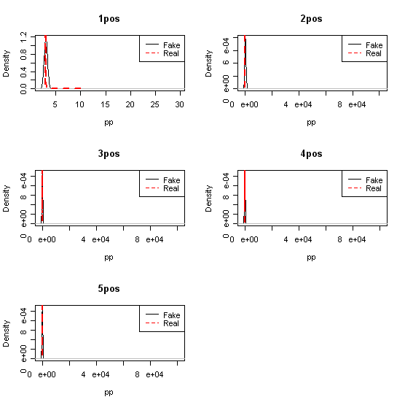

From the above graphs, we can see that the informative features might be the perplexity of the unigram and bigram, the bigram and trigram on the fake sentence's part of speech. But when we add them into the feature set, it does not improve the performance. One possible explanation is that we already achieve 90.0% accuracy at that point. This information is already represented by the combination of other features.

4.2.2 Frequent N-gram feature:

Using the most frequent words and POS sequence model, we also investigated the usage of following features:
- The most frequent unigram and bigram and trigram occurring on the 100M data set.
- The most frequent 1~5 gram of the POS of the 100MW dataset

We choose to consider the top-500 possible unigram and bigram sequences in the 100MW dataset as well as POS sequences. If we consider them separately, we will daintily have a large spare feature matrix which that is susceptible to over fitting. To solve this problem, we use linear weighted sum. That is we give each frequent word a weight, this weight is decided by its frequency at the 100M corpus. Then on the training article, if we see a word once, we add them according to their weight. This generation policy is based on the assumption that for those highly likely word sequences, the distribution of them is not the same in the fake sentence as in the real sentences.

Following is the distribution of the features on fake sentence and on real sentence:

From this graph, we find that the top likely sequence almost have the very same distribution on the training set as well as on the test set. Only for the unigram, there is a slightly different between the true sentence set and the fake sentence set. The above graph suggests that the most likely sequence either in POS or in words is not very informative. Actually we try to use this feature, but it shows slight degrade on the performance of the accuracy. This result really makes sense, since for those frequent grams, we have a very good MLE estimation so fake and real sentences will look a like and their difference is just amount to the variance in the MLE estimation which was viewed from the classifier point of view as a noise that degraded its performance.

In fact we regretted that we used these features, as later one we realize the 3-gram unfairness regarding rare event and hence we should have considered the lowest as opposed to frequents event but we didn't have much time to explore this direction in full details but we explored it a little bit as detailed our modeling of proper nouns in the semantic features. If we have more time, we could even better selected grams whose counts differ significantly in both corpuses using measures like Chi-square of hypothesis testing.

4.2 Syntactical Features

In this part to tried to measure grammatical correctness of a given sentence or grammatical coherence of a given article passed on statistics over grammatical features. We divide these into POS-based features and Parsing-based ones.

4.2.1 POS Features

We used the maximum-entropy MXPOST part-of-speech (POS) tagger as described in [Ratnaparkhi 1996]. The original tagger was trained on section 1-18 of the Penn Treebank. Because in the original Treebank, information such as punctuation, capitalization was present, but we do not have the same type of information in our training or testing data, we stripped off all the punctuation in the original Treebank, and also turned every character into capitalized, and retrained the POS tagger.

We then used our newly trained POS tagger to tag to the whole 100MW corpus, and from that we collect the following statistics. The probability of each possible POS tag (there are 36 in total), we use these probabilities as weight for each of the POS tags. The first feature we used was the ratio of content POS (such as Nouns and Verbs) vs. non-content POS. We then go through each sentence’s POS correspondence in an article, and add up all the weights of the POS tags at the beginning and ending position, and average over sentences numbers. Other features we used were POS at beginning and ending position's probability across all possible POS; each has an averaged value (so this gives 72 features). We also calculated POS at all position's probability across all possible POS (36 features). After feature selection, we found that only some POS’s beginning and ending probability features, plus some POS’s average probability across all possible positions were helpful. Some of the useful feature’s distribution diagrams are drawn here:

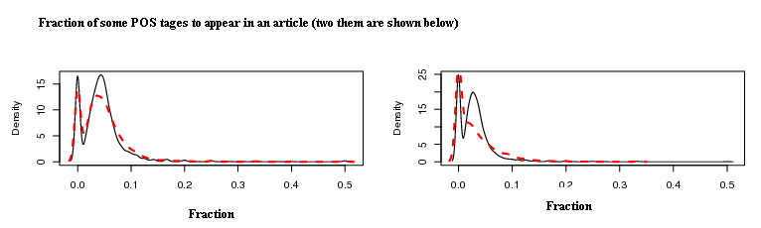
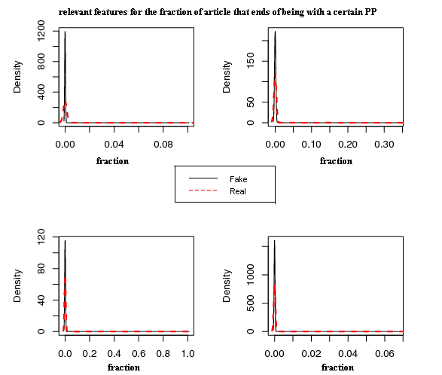

4.2.2 Parsing Features

Inspired by the work in Charniak 2001 on using immediate-head parsing for language models, we adopted Charniak’s parser and retrained the model on the Penn Treebank section 1-22. The parser outputs perplexity of sentences based on an immediate-bihead model (grammatical model) and an immediate-trihead model [Charniak 2001]. Results report in Charniak 2001 showed significant improvements over traditional trigram models. (24% for tri-head and 14% for bi-head). Because we are working at article level, we have to take into account the perplexity of each of the sentences occurred in the article. We tried several different features. The first set of features is the averaged log-probabilities from the grammatical model, trigram model and a mixture model. Then we averaged each of these average log-probabilities over the number of words in each sentence. This gives us an additional three features. We also find the maximum and minimum log-probabilities of a single sentence, among all sentences within an article, plus the maximum and minimum log-probabilities averaged over words of a single sentence. These features are numbered and listed here:

1.log-grammar-probability 2.log-trigram-probability 3.log-mixed-probability 4.log-grammar-probability per word 5.log-trigram-probability per word 6.log-mixed-probability per word 7.max sentence log-grammar 8.max sentence log-trigram 9.max sentence mixed 10.max sentence log-grammar per word 11.max sentence log-trigram per word 12.max sentence mixed per word 13.min sentence log-grammar 14.min sentence log-trigram 15.min sentence mixed 16.min sentence log-grammar per word 17.min sentence log-trigram per word 18.min sentence mixed per word
At the end, based on feature selection strategy that will be described in later sections, we finally selected features 2, 7, 8, 9, 10, 11, 13, 14 as the most informative ones among these parsing-based features. The distributions of some of these features are plotted below:
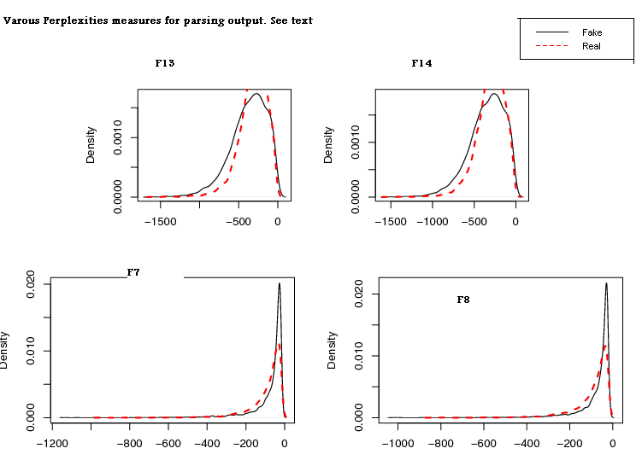

4.3 Semantic Features

One draw back of the 3-gram model is that it lack global context, a phenomena which is critical in real article. Usually, a real article exhibit semantic coherence that can be captured via many ways: coherence of content words, burst-ness, style, and usage of proper nouns. The following subsection will detail these features.

4.3.1 Modeling Coherence of Content Words

Real document exhibits coherence in a sense that it addresses a small number of topics, where each topic is a probability distribution over words and since topics have different probability distribution over words, we don't exhibit that all word groups would appear uniformly. For instance if we see the words soccer, player, coach in an article we expect to see words like stadium, score, ball, goalkeeper, etc. more than words like education, research, paper, and vice versa. Since documents might speak about different related topics like health and sport or education and funding, we expect that words form the same topics tends to appear near each other.

Putting all things together, we expect that nearby words tends to be semantically related to each other. We decided to use the words-pairs point-wise mutual information [Manning 1999] as a measure of this semantic coherence. This measure capture statistical dependency between words, in essence, it is high for words for which P(W1|W2) is greater than P(W1) or vice versa, in other words the appearance of once words is a good indicator that we will see the other on nearby in the test. However, this measure is also used to capture collocations or compound words like (white house) which are captured well but our 3-gram model as it relies on local statistics. Hence we used a measure we call distant collocations, that is we consider two words to co-occur only if they appear in a distant window, for instance if W1 appears at position 4 in the article, we only consider words that appear from position [4+lower , 4 + upper]. We chose lower to be 2 to rule out dependencies and upper to be 10 to capture the centered nature of topic occurrences and not to smooth out the measure. Using our above definition of C(W1, W2) and the usual definition of C(W1), C(W2), we plug them into the standard point wise mutual information formula to measure how related they are. To avoid hijacking form stop words, we only consider content words during the whole analysis. We used a freely available package to get that measure [Ted Peterson 2006].

$$\text{PMI}(W_{1},W_{2})=\text{log}\left(\frac{P\left(W_{1},W_{2}\right)}{P\left(W_{1}\right)×P\left(W_{2}\right)}\right)$$

After getting the top word-pairs with their PMI score, and given an article, we first remove all stop words, and then we compute the following score:

$$\begin{aligned}\sum_{w_{i}∉\text{StopWord}}{}w_{i}∈D\end{aligned}\frac{}{\left(\text{content}\text{ words}\right)}$$

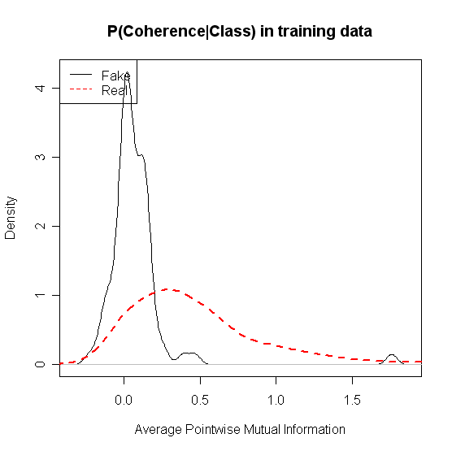
The window size [5,13] was based on cross validation. The figure above shows the condition distribution of this feature in fake and real articles. It is evident that this value is higher in real article in contract to fake one that tent to have assigned low value to this feature with high probability.

4.3.2 Modeling Burst-ness

Another property of real document is that once a word occurs in a document it is likely to occur again, a feature that allows most text document to have a high compression ratio. To capture this feature we calculate the entropy of content words in a document. We first remove all stop words, and then stem the remaining words using porter stemmer, and then estimate the empirical distribution of words that appear in this document using MLE (i.e. simple counting) and finally calculate the entropy of this distribution. To get a consistent measure across document of varying length, we divide this measure by log(# of content words), which gives us a good measure of the compressibility of a document since the log(log(# of unique content words) is the average number of bit if the words are uniform, and the entropy is the document bits per word.

$$\begin{aligned}\sum_{w_{i}∉\text{StopWord}}{}w_{i}∈D\end{aligned}\frac{}{\left(\text{unique content words}\right)}$$

where ${\tilde{p}}_{D}$ is the empirical count (MLE estimate).

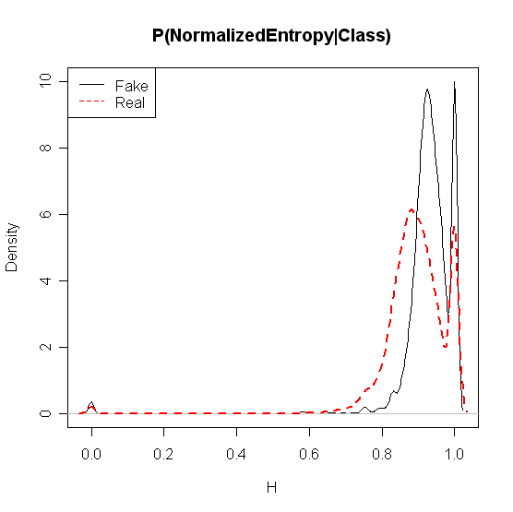
Figure above show the conditional distribution of this feature given the class label in both training and testing set. Real documents tend to have low values of this measure. The curve to some degree captures this intuition but it should be taken into account. If we have more time we could have plotted this distribution for various document lengths as we expect this feature to be more robust for high document.

4.3.3 Modeling Style
Although stop words are knows to be non-informative bearing content, we tried to make sense out of them. We hypothesized that due to their high marginal probability, then will tend to occur uniformly within fake articles, yet expect that real article will have a style element in a sense that not all of these stop words will be equally likely (for instance someone could rarely use moreover but use therefore a lot, etc.). To capture that, we compute the normalized entropy of stop words appearing in a document in a similar way to that of section 4.2.3. The distribution is shown below. We can conclude that it looks very similar to that in 4.2.2 which means that style and bust-ness are more of less the same aspect.
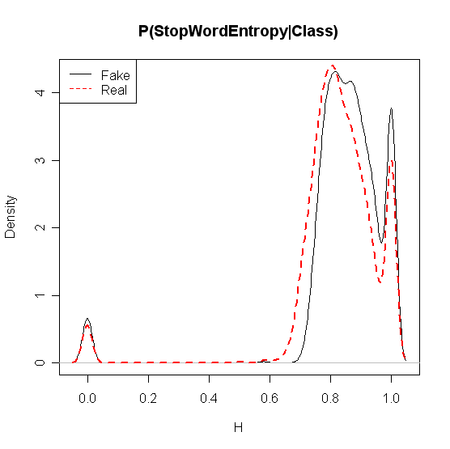
4.3.4 Modeling Proper-noun novelty rate

The intuition behind this feature is that if proper-nouns such as person names and locations that do not occur often in documents appear more than twice in an article, it is a kind of indication of the semantic coherence of the document. Our assumption is that in fake articles, such rare words are not likely to occur many times. So we created a ranked list of all the words in the 100MW corpus according to their number of occurrences. And we set the threshold value to be 1000 (this is selected based on a range-based cross-validation test), any word that has occurred less than 1000 times will be considered rare. Then we scan the article, and find all “rare” words that appeared more than once. Then we sum up for each of such rare words, the number of occurrence times the inverse of their occurrences in the 100MW (resembles the tf/idf in a way), and finally normalize it. This feature’s distribution is plotted below:

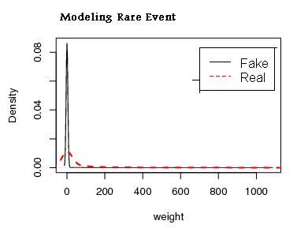

5. Feature Selection and Tuning

Considering all of these numbers of features, we don't expect a good performance if we just put all of them together as they might act as a noise or we might over fit. Even worse, some features require a threshold value that needs to be tuned. The best approach to solve all of these problems is to use k-fold cross validation, however CV is computationally very expensive over the product space of these feature combinations. So we went with the following approach.

We first estimate the likelihood of the feature given the class label suing non-parametric kernel-based density estimation via a build in package in the statistical package R. Then using visual inspection we rule out many non-informative or duplicate feature. Then using the same technique we do a coarse based tuning of threshold for other features, i.e. we seek threshold that separate the conditional distribution of the feature in the two classes (we might over fit here, so we just make it a coarse range), then we fine tune it using cross validation. After deciding on the best features on each category (lexical, semantic, syntactical), we use 10-fold CV to combine them and select the combination that result in the best performance.

After that we fine tune the classifier parameter over this combination. Somehow, this can be viewed as doing a coordinate ascent over our selection space! For the classifier we used SVM suing the LIBSVM package that output class probabilities as well by fitting a logistic regression to the margin of each example as produced by the SVM classifier. For the kernel choice, we used radial basis kernel and tune its parameter using cross validation. Finally we trained the final classifier on the whole data we have (training + development)

6. Experimental Results

The following table shows the classification accuracy of various feature combinations reported on the development set.

Features used* | Accuracy on development Set | Soft measure**
Sem | 84 % | -0.4
Sem + PrpoerName | 84.5% | -
Sem + Parsing | 88.5% | -
Sem + POS1 | 83% | -
Sem + POS2 | 85% | -
Sem + POS3 | 84.5% | -
Sem + Parsing + POS3 [22 features] | 90% | -0.28
Sem + Parsing + POS3 + top_N_Gram | 84.5% | -
Sem + Parsing + POS3 + top_1_Gram | 89.5% | -
Sem + Parsing + POS3 + 1_gram_Prep | 89.5% | -
Sem + Parsing + POS3 + N_Gram_Prep | 84.5% | -
Sem + Parsing + POS3 + POS_Perp | 61% | -
Sem + Parsing + POS3 + FPO_Perp | 72.5% | -
* see legend below
** not available for all models due to time limitations, as we were only able to figure out how to get probability estimate from SVM classifier later and we didn’t have time to re-train the model (to get prob, we need to retrain the whole model again to fit the sigmoid curve)

Legend
- Sem = NormalizedEntropy, Coherence, ratio of content words to stop words (see 4.3.1, 4.3.2, 4.3.3)
- Parsing = features 2, 7, 8, 9, 10, 11, 13, 14 in section 4.2.2
- ProperName = See section 4.3.4
- POS1 = ratio of nouns+verbs+adj+adv to the rest,
- POS 2 = 36*2 features: fraction of time each POS appear as end or begin of a sentence (7 of them only pass feature selection)
- POS 3 = distribution of some POS (like CC) in the article (approx. 4 of them)
- TOP_N_GRAM = see section 4.1
- TOP_1_GRAM = see section 4.1
- N_GRAM_PERP = article perplexities under 1,2-gram LM
- POS_PERP = article perplexities under 1~5-gram LM over POS in the BN corpus.
- FPOS_ PERP = article perplexities under 1~5-gram LM over POS in the fake corpus

Notes

- Semantic features have a very discriminative power, with only 3~4 features we got up 84%. When we also looked at exampled we missed, we realized that they are short ones, which means for articles whose length are greater than 3, we got 99% of them correct. This also could say that other techniques are needed for shorter articles.
- From the feature distributions, we expected unigram (top and LM based) features to be of help. But when we added them into the feature set, it does not improve the performance. One possible explanation is that we already achieve 90.0% accuracy at that point. Unigram information is already represented by the combination of other features.
- We also expected that Proper nouns feature to be of help (see section 4.2.4) but when we implemented this feature and tested on the development set, it brought down our accuracy from 90% to 89.5% by 0.5%. We think that one of the reasons why this feature does not work as what we expected is because in the training and testing article, true rare words are removed and replaced with the OOV marker <UNK>….this eliminates the chances for us to get a lot of the real rare words.
- Parsing was indeed useful but not as expected, we hypothesize that parsing has some rule in getting some short articles correct. We also noted that averaging grammatical features like parsing over the whole sentences tends to flatten this measure a lot.
- Scaling the feature DOES help! For example suing the parsing feature that range from -1000, 1000 with other features that range from [0,1], moved the model with semantic features from 84 → 50%!!! Yet after scaling it moved it up to 88.5%
- Short sentences are really hard to be classified. Out of the 20 examples in the training set we got wrong, 13 were one-sentence! We believe that there should be different features for short and long sentences.

Table 2 Accuracy per Article Length
Length | 1 | 2 | 3 | 4 | 5 | 7 | 10 | 15 | 20
Accuracy | 70% | 85% | 85% | 95% | 95% | 100% | 100% | 100% | 100%

Precisions –Recall Matrix
Class | Recall | Precision
Real | 93% | 87%
Fake | 87% | 92%

7. Lessons Learnt and Possible Extensions

In this section we will list several lessons we learnt from this project and possible extensions that we would have liked to pursue if we had a little more time. First we start with the lessons:

- NLP is hard (if u want to beat humans)
- NLP is easy (80-20 rules, with 4 features we got a decent classifier)
- NLP is a lot of FUN. (that is out of the question otherwise we wouldn't be in this class!)
- Nothing could have been better than seeing how things work in practice. We gained many insights in aspects that we never looked at before.
- Feature selection is important, cross validation really helps and visual inspection of feature distribution per class, when combined with CV, can scale feature selection.
- The distribution of training and testing data make a difference. Being distribution invariant is really hard, so incorporating whatever we know about the test distribution would help a lot. CV would not make any sense if the two distributions are different. (CV is only unbiased estimate of the true risk when example will be drawn from the same distribution)

And here are some possible extensions we omitted due to lake of time:

- Using different classifier for short and long articles. We believe that discriminative features are different for both of them and our feature selection scheme bias us toward getting articles greater than 5 totally right. (see table 2)
- Linguistic knowledge would help for shorter sentences or shorter articles. Averaging them as we did smoothes out them and makes them less reliable.
- Injecting WordNet based information to measure similarity and coherence. (is-kind-of concept might be useful)
- Using LDA to measure topicality and coherence. We though about using the entropy of the final topic mixing proportion as an indicator of coherence.
- Building higher order n-gram models like up to 7.
- Selecting N-gram patterns (lexical and POS based) that show large variance in the two corpus.

References

[Charniak 2001] Eugene Charniak, 2001, Immediate head parsing for language models, Proceedings of the Thirty-ninth Annual Meeting of the Association for Computational Linguistics.

[Manning 1999] Christopher D. Manning & Hinrich Schuetze (1999) Foundations of Statistical Natural Language Processing, MIT Press, Massachusetts

[Ratnaparkhi 1996] Adwait Ratnaparkhi, 1996, A Maximum Entropy Part-Of-Speech Tagger, Proceedings of the Empirical Methods in Natural Language Processing Conference.

[Ted Petersen 2006] Ngram Statistics Package (NSP) available at http://www.d.umn.edu/~tpederse/nsp.html.

